**Flow Chart:**

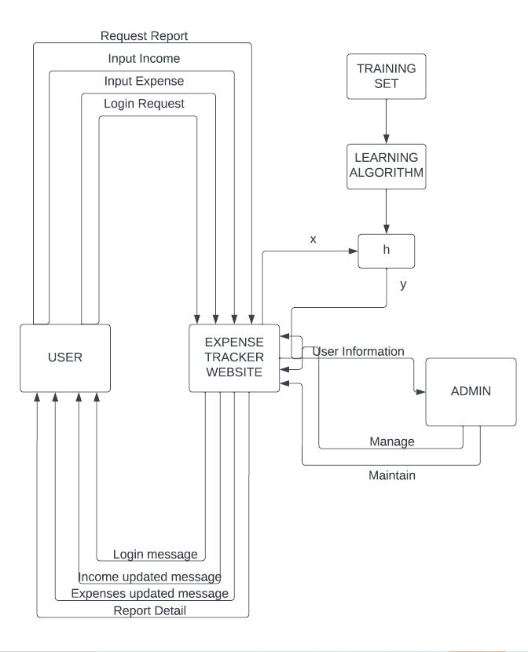

**DFD:**

**DFD 0:**

**DFD 1:**

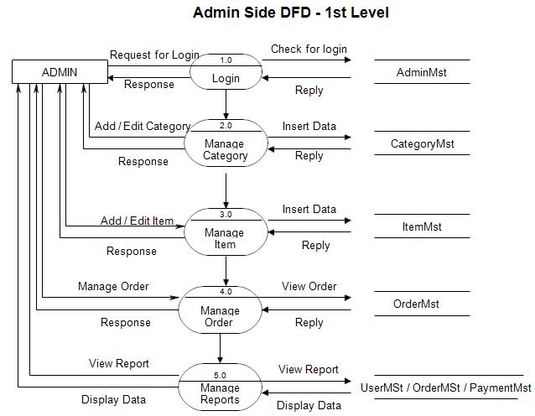

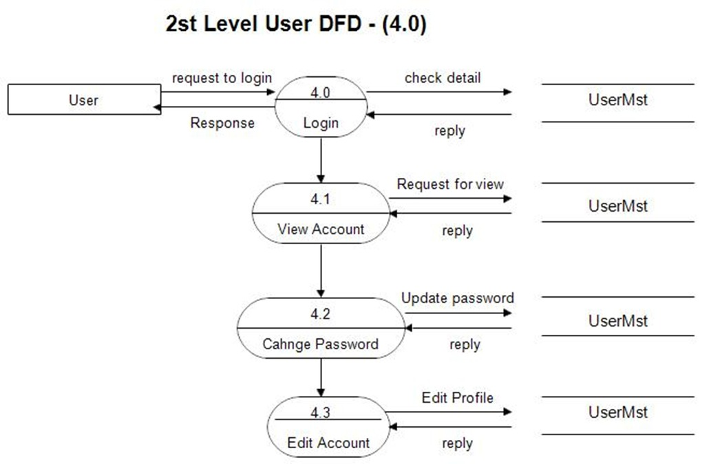

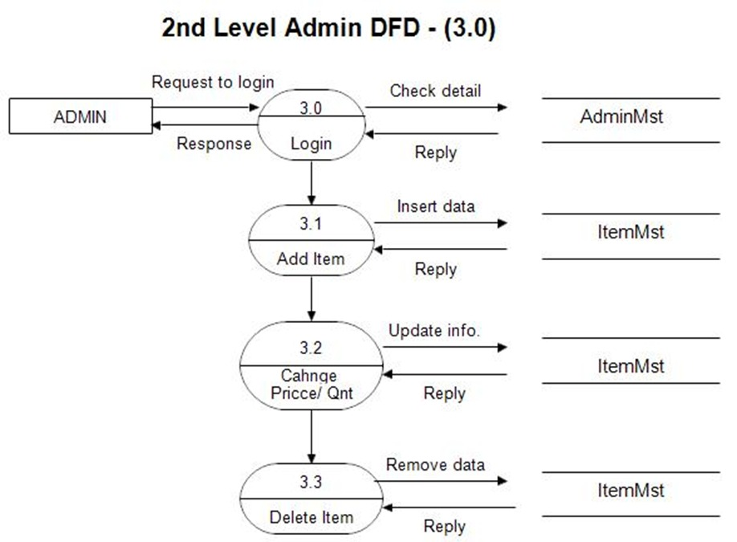

**USE CASE DIAGRAM:**



